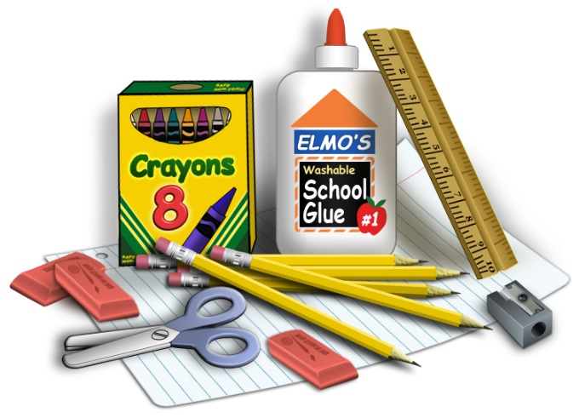
Kindergarten Wish List

Dear Kinder families,
Here is a list of items we use throughout the 25-26 school year. If you are able to contribute to your child’s classroom, we would appreciate it. Please see your child’s teacher if you have questions. Thank you!

Playdoh
Lysol Wipes
Kleenex
Glue Sticks
Ziploc bags
Hand sanitizer
Paper towels
One 1-inch 3 ring binder

